28.85: The charge on a ring of radius r is 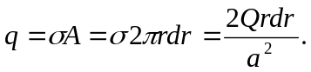 If the disk rotates at n turns per second, then the current from that ring is:
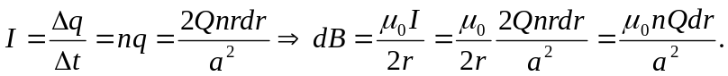
So we integrate out from the center to the edge of the disk to find:

